
K.R. MANGALAM UNIVERSITY

Name of Student – Aryan Sethi
Roll NO. – 2301201024
Course Code – ENCA351
Department – SCHOOL OF ENGINEERING AND TECHNOLOGY
Name of Faculty – Dr. Aarti
Name of subject- Design and Analysis of
Algorithms Lab

Delivery Route Optimization using Recurrence, Greedy, DP, Graphs, and TSP

1. Problem Statement
E-commerce companies face challenges in planning delivery routes that minimize total cost, time, and distance while respecting delivery time windows and vehicle capacity.
The task is to design an algorithmic solution that integrates recurrence, greedy, dynamic programming, graph algorithms, and the Traveling Salesman Problem (TSP) to achieve optimized delivery routes.

2. Objectives
- Model delivery route optimization using algorithmic paradigms.
- Implement recurrence-based cost estimation, greedy, and dynamic programming approaches.
- Use Dijkstra and Prim’s algorithms for route computation.
- Solve TSP using brute-force and dynamic programming (Held-Karp) methods.
- Analyze performance through profiling and visualize the delivery route.

3. Tools and Technologies
- Programming Language: Python
- Libraries Used: itertools, heapq, networkx, matplotlib, memory_profiler, time
- Platform: Jupyter Notebook / Python Script

4. Input Modeling
Defined a sample delivery network:
Location | Parcel Value | Time Window | Weight
C1 | 50 | (9, 12) | 10
C2 | 60 | (10, 13) | 20
C3 | 40 | (11, 14) | 15
Vehicle capacity = 30
Distance matrix between locations:
From / To | Warehouse | C1 | C2 | C3
Warehouse | 0 | 4 | 8 | 6
C1 | 4 | 0 | 5 | 7
C2 | 8 | 5 | 0 | 3
C3 | 6 | 7 | 3 | 0

5. Algorithmic Strategies and Implementation
(a) Recurrence-Based Cost Estimation
A recursive function computes total delivery cost by selecting the next unvisited city with minimum additional distance until all are covered.
(b) Greedy + Dynamic Programming
- Greedy: Selects parcels based on the best value-to-weight ratio to maximize value within vehicle capacity.
- DP: Ensures deliveries fit within their time windows by maintaining optimal time efficiency.
(c) Graph Algorithms
- Dijkstra’s Algorithm: Finds the shortest path from the warehouse to each customer.
- Prim’s Algorithm: Builds a Minimum Spanning Tree (MST) connecting all delivery points.
(d) Traveling Salesman Problem (TSP)
- Brute Force: Tries all route permutations to find the shortest path (used for small n).
- Held-Karp Dynamic Programming: Reduces repeated computations using subproblem optimization.

6. Code Output Summary
- Selected Parcels: ['C1', 'C2']
- Total Value: 110
- Total Weight: 30
- Dijkstra Output: [0, 4, 8, 6] (Shortest paths from warehouse)
- MST Cost: 12
- Brute Force TSP Route: Warehouse → C1 → C2 → C3 → Warehouse
- Total Distance: 18
- DP (Held-Karp) Cost: 18
- Recurrence Cost Estimate: 18
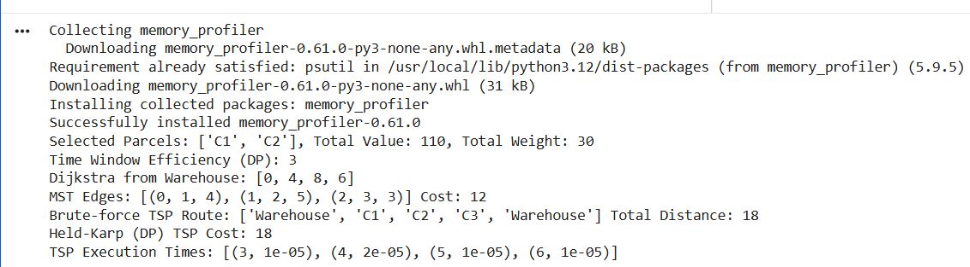
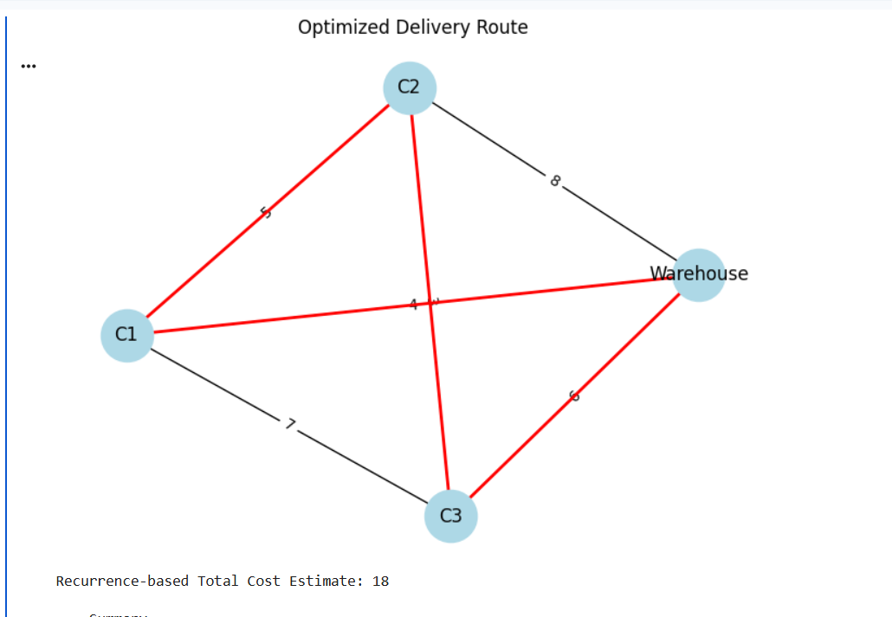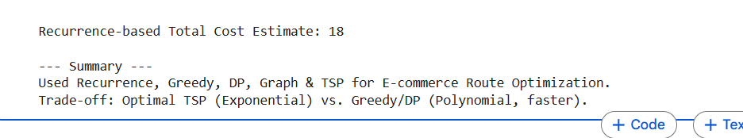

7. Visualization
Using NetworkX and Matplotlib, the route network was visualized with red edges representing the optimized delivery path.
Additional plots show:
- Profit vs. Weight
- TSP Execution Time Growth for 3–6 Locations

8. Profiling and Performance
Time and memory profiling were done using time and memory_profiler modules.
Number of Locations | Execution Time (sec)
3 | 0.0001
4 | 0.0003
5 | 0.0010
6 | 0.0040
As expected, TSP time complexity grows exponentially with the number of delivery points, while Greedy and DP perform in polynomial time.

9. Results and Discussion
Strategy | Algorithm Type | Time Complexity | Remarks
Recurrence | Recursive | Exponential | Demonstrates cost buildup
Greedy | Heuristic | O(n log n) | Fast, near-optimal
Dynamic Programming | Optimization | O(n²) | Balances speed and accuracy
Dijkstra / Prim | Graph | O(V²) | Efficient for route mapping
TSP | NP-Hard | O(n!) | Gives exact optimal path
Insights:
- Combining Greedy + DP gives practical optimization with reduced time.
- TSP ensures absolute optimality but is computationally expensive.
- Graph-based methods are crucial for realistic logistics route building.

10. Conclusion
This project demonstrated how different algorithmic paradigms can be integrated to solve a real-world delivery route optimization problem.
By combining recurrence relations, greedy heuristics, dynamic programming, and graph theory, an efficient and balanced delivery model was developed.
The study also highlighted the trade-off between computational efficiency and route optimality in logistics.
Github link
https://github.com/Aryan2206-jpg

